Steps to Migrate Out and Migrate In :

POST Method

URL: <https://dev-api.fidelity.co.uk/gds/apigee/v1/migrate/out>

Body : {

"api_name":"im-performance-v1",

"revision": "14",

"repo_corp_id": "a586079"

}

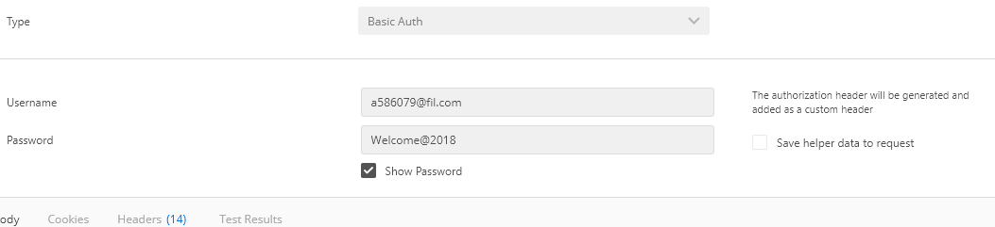

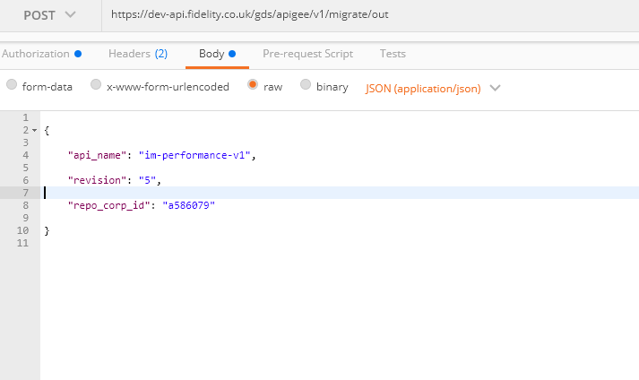

SEND Request.

Response in BODY: {

"code": "200",

"message": "Jenkins job initiated, please wait...",

"git_repo": "https://bitbucket.bip.uk.fid-intl.com/projects/APIGEE/im-performance-v1",

"jenkins": ""

}

**MIGRATE IN**

**POSt request**

<https://dev-api.fidelity.co.uk/gds/apigee/v1/migrate/in>

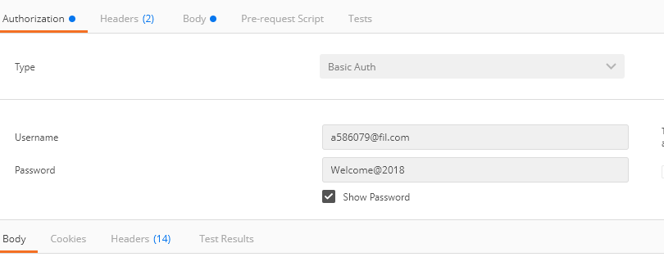

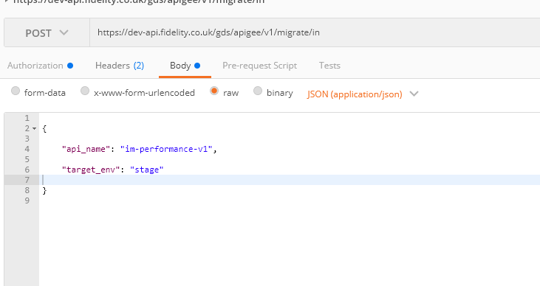

Send Request

Response:

{

"code": "200",

"message": "Jenkins build initiated, please wait..."

}

After this, we will get an email that would mention client id and client secret.

Confluence Documentation:

<https://confluence.uk.fid-intl.com/display/DIGSEC/FIL+APIGEE>

Bit Bucket Link :

<https://bitbucket.bip.uk.fid-intl.com/projects/APIGEE/repos/im-performance-v1/browse/apiproxy/im-performance-v1.xml>